15015 | Document Code
00 | Revision

Software Architectural Design

Device Name: Dental Laser
Software Safety Class: B
Driver Software Version:01
GUI Software Version: 7.0.0.7650

Signature | Date of Issue | Approved by | Confirmed by | Prepared by | Issue Details | Rev. No.
 | 04/29/2024 | Beik Y. | Bagheri M. | Pourirahim S. | Initial Release | 00

1. Architecture of Software

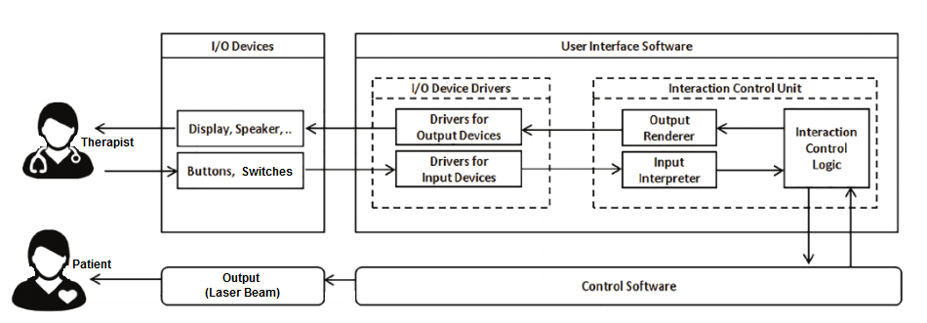
Figure 1- General interfaces with the device

According to the figure 1, interaction control logic deﬁnes the procedures through which the user interacts with the device, coordinates with the control software to respond to user inputs, and determines the content and timing of information and feedback to be presented to the user. Drivers for input devices are responsible for detecting user actions on input devices, such as press/release of buttons, and touch events on touchscreens.
Input interpreter handles complex user input events, such as long-press actions on input widgets, mapping between touchscreen coordinates and input widgets rendered on the touchscreen, and continuous user actions on input devices, such as pedals. Output render deﬁnes how feedback is presented to the user, such as the format and layout of on-screen information. Drivers for output devices command output devices (e.g., displays, speakers) to present feedback to the user in a manner deﬁned by the output render.
Dental Laser N310 and N210 devices have two pieces of software (Figure 2). Driver software tasks are to control and adjust the device's output. GUI software provides a Graphical User Interface (GUI) between user and the device. Communication between GUI and Driver software will be fulfilled through serial communication protocol (RS-232).
Figure 2- Software of Dental Laser system

1. LCD Module: The GUI software generates the data to be displayed on the LCD, which can include text, images, icons, and other graphical elements. The user can view and interact with the information presented on the screen. If the LCD is touch-enabled, the GUI software can receive user input from the touch panel. It interprets the touch coordinates and performs appropriate actions based on the user's interaction.

2. Sound Module: The GUI software processes the user input data to determine the desired volume levels for the touch and buzzer functionalities. Once the desired volume levels are determined, the GUI software sends the corresponding data to the sound module of the device.

3. Wi-Fi module: The GUI software communicates with a remote server to determine if any updates are available for the device. If an update is available, it downloads the update package from the server. This package contains the necessary files and data to upgrade the device's software. Once the user confirms the update, the GUI software initiates the update process. It manages the transfer of the update package to the device via the Wi-Fi module.
4. Storage Flash Memory: To save therapeutic protocols, placement images, error messages and other user settings, a storage flash memory is used.
5. Battery: The microcontroller continuously monitors the battery voltage level using the ADC. It compares the voltage against predefined thresholds that indicate the battery's state of charge or health. By analyzing the battery voltage readings, the microcontroller can determine the remaining battery capacity. If the battery voltage drops below a specific threshold, the microcontroller can generate a low battery warning. This warning can alert the user to recharge or replace the battery to ensure uninterrupted operation of the dental laser device. Additionally, the microcontroller can implement battery protection mechanisms to safeguard against overcharging or deep discharging, both of which can potentially damage the battery. It can control the charging circuits to regulate the charging process and protect the battery's integrity.
6. Temperature Sensor: Temperature Sensors outputs have an exponential (nonlinear) relation with temperature which means for every degree rise in temperature, the output of the sensors will rise nonlinearly. One sensor is used to measure the laser diode temperature and another one is used to control the temperature of the device battery. These measurements are sent to the Driver's Microcontroller to control the fans and output laser.
7. Fiber Sensor: This sensor is able to recognize if the optic fiber is not connected to the device. This data is sent to the Driver's Microcontroller and then to the GUI Module to warn the user.
8. Footswitch: The Microcontroller controls the Footswitch State (pressed or released). If the footswitch is connected, the Microcontroller is waiting for pressing its switch to start applying output laser wave. In addition, the sensor is able to recognize if the footswitch is not connected to the device. This data is sent to the Driver's Microcontroller and then to the GUI Module to warn the user.
9. LED: The dental laser device includes an LED that is responsible for indicating the status of the laser radiation module. The microcontroller controls the LED, allowing it to change colors to represent four different modes: off, standby, ready, and emitting. Each mode is associated with a specific color.
10. Cooling system: By controlling the cooling system including TEC and Fan, through the microcontroller, the dental laser device can effectively regulate its temperature, providing optimal performance and preventing overheating. In details, the microcontroller controls the operation of the Thermoelectric Cooler (TEC). It can adjust the power supplied to the TEC to either heat or cool the device, depending on the current temperature conditions. In addition to the TEC, the microcontroller also controls the fan within the cooling system. It can regulate the fan speed to increase or decrease the airflow, aiding in temperature regulation.
11. Interlock: The driver software constantly monitors the status of the interlock key. Upon key insertion, it triggers the activation of the locking mechanism, which physically disables the laser beam emission and relevant functions. The device remains locked until the interlock key is utilized once more. It detects when the key is removed, prompting the activation of the unlocking mechanism. Subsequently, the device is unlocked and ready for use.
12. Laser Module: The dental laser device is equipped with a laser driver circuit that provides the necessary electrical power and control signals to the laser module. This circuit is connected to the microcontroller.
13. Aiming beam controller: By integrating the Aiming Beam Controller with the microcontroller and providing user control through the GUI software, the device enables the user to adjust the intensity of the aiming beam according to their preferences and specific requirements.
14. Interface between GUI Module and Driver's Microcontroller: There is a serial communication protocol (RS-232) between GUI software and Driver software. The following information is sent from GUI Module to the Driver's Microcontroller (STM32F207)
- Error Commands
- The Output Mode which has been selected by user through GUI: Continuous-Pulsed.
- The value of output Power, Duty Cycle, Timer, Wavelength which has been selected by user through GUI
- The value of Frequency which has been selected by user through GUI
- Emission mode which has been selected by user through GUI (Standby/Ready/Emitting Mode)

The following information is sent from Driver's Microcontroller to GUI Module:
- Error command (e.g. Fiber or Footswitch Disconnection command)
- Footswitch state (Pressed or released)
- Temperature
- Battery State

A) GUI Software
In this section, GUI software requirements have transformed into the ARCHITECTURE that describes the software's structure and identifies the SOFTWARE ITEMs.

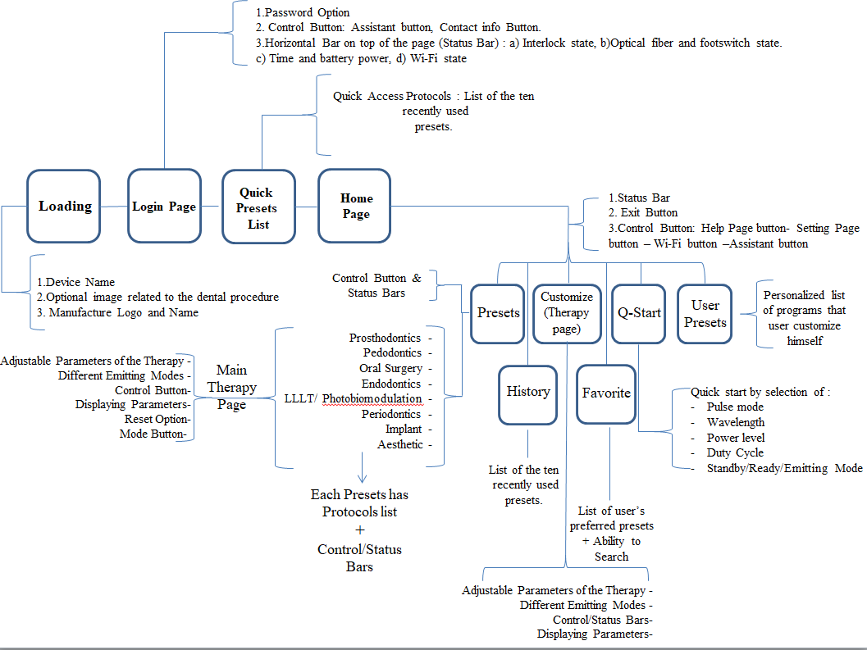
Figure 3-GUI of Dental Laser Device

Loading and Login Page:
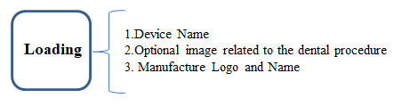
Figure 4- GUI of the Loading page of Dental Laser Device

After Loading Page including Device Name and Manufacture Logo, to enhance security and safety, each user is required to set a four-digit password. The device also comes with a default password pre-defined. On this page, the user will find four options:
1. Assistant Button: This button provides descriptions of the default passcode and information about each button's functionality.
2. Contact Information Button: This button provides the mobile number, address, and email of the company's "After-Sales" department.

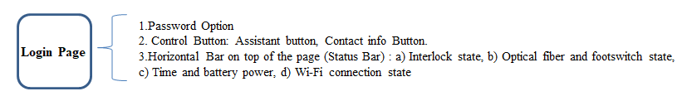
Figure 5- GUI of the Login page of Dental Laser Device

Additionally, there are several status icons that indicate the status of various items, which are present on every page of the software (even in login page). These icons include:
• Wi-Fi status (connected or disconnected)
• User type (expert or quick)
• Footswitch connection (connected or disconnected)
• Fiber connection (connected or disconnected)
• Interlock connection (connected or disconnected)
• Time and battery charge percentage and graphics.

2. Quick Presets List

The list of recently started presets by the user (10 items) is saved in this page.

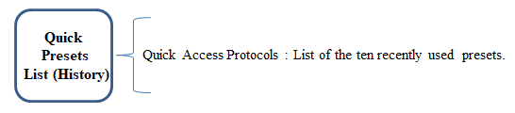

Figure 6- GUI of the Quick Presets List page of Dental Laser Device

3. Home Page
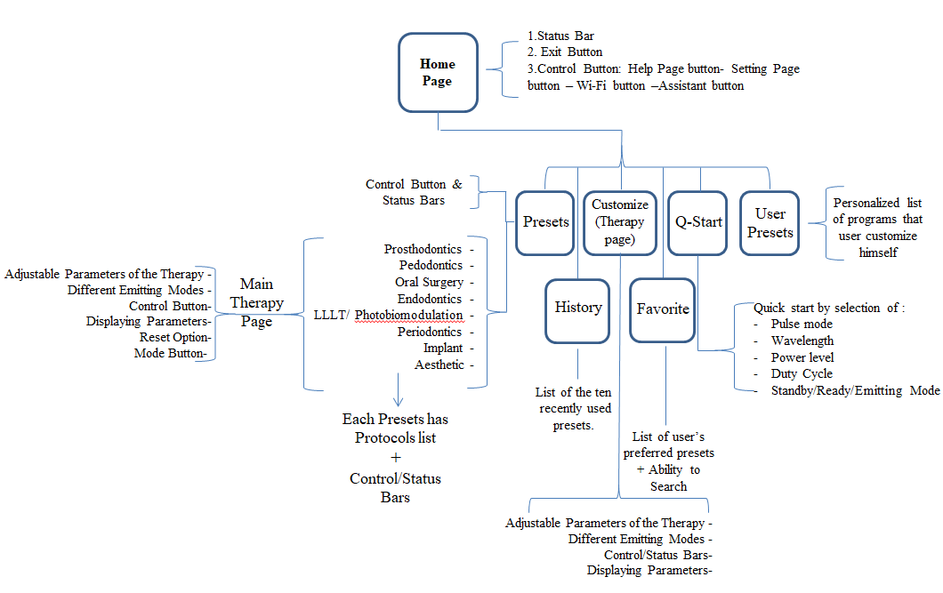
Figure 7- GUI of the Home page of Dental Laser Device

Once the device is powered on and the software is loaded, the Home page will be displayed. It includes different icons.
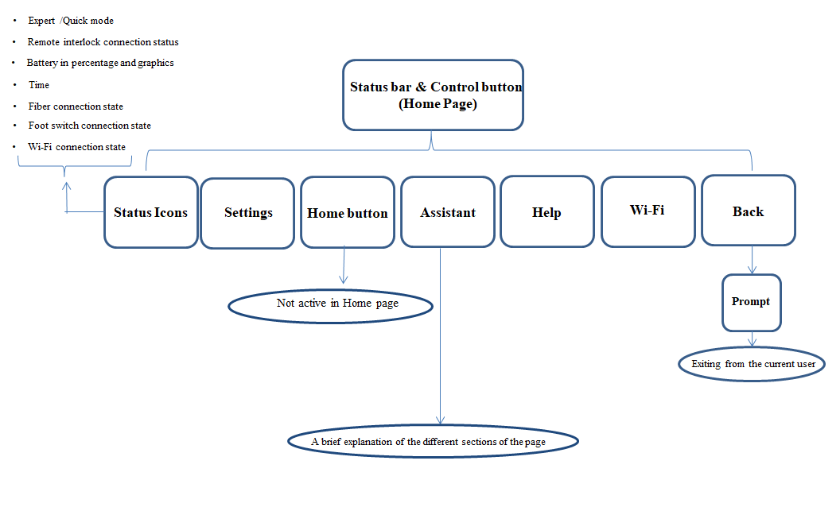
Figure 8- The Block diagram of Control Bars of the Home Page

3.1. Adjustable Icons

1. Back Button: Generally, the Back button allows navigating to the previous page. However, on the Home page, pressing the Back button will prompt a confirmation message asking if the user wants to exit the current user. The user should choose either "Cancel" or "OK" to proceed.
2. Control Button: By selecting this button, a list of options showed up including:
- Assistant: Each page has its assistant sheet which explains items on the page. By touching the assistant icon, a window is opened that describes all the symbols, icons, and names used on the home page. This page can be easily closed by touching the "close" icon. ‘Assistant' of each page is based on the information provided in the same page.
- Wi-Fi: By tapping on this button, the user can access the Wi-Fi subpage, where they can connect to or disconnect from the desired network.
- Help: By tapping this icon, users can access the following options: Dental Laser Introduction, Device Introduction, Device Information, and Contact Information.
- Device Info: Provides information about the device, including its model, serial number, manufacture date, maximum power, wavelength, presets version, and software version number. The "Presets version" and "Software version number" can be updated if the device is connected to Wi-Fi.
- Settings: The Settings menu offers the following options:
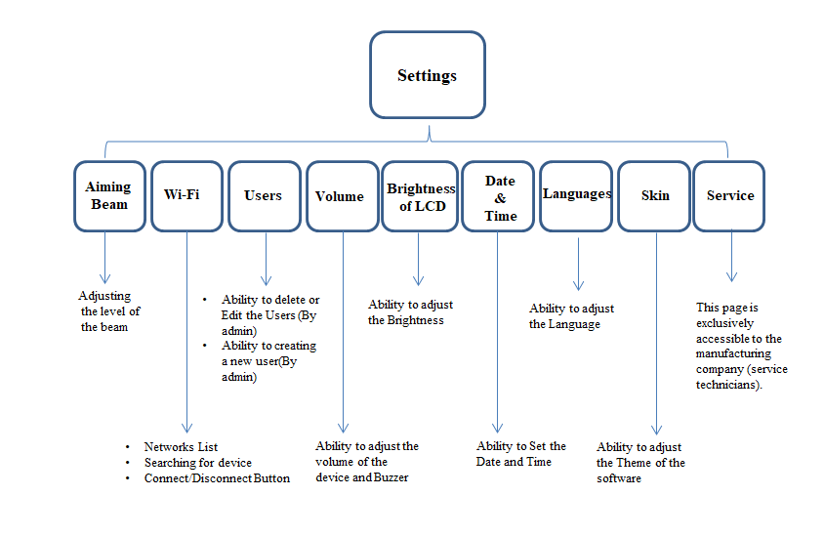
Figure 9- Setting block diagram

- Wi-Fi: This option enables users to connect to or disconnect from their desired network.
- Users: The Admin has the ability to create, edit, or delete user accounts. The admin account is editable and other users’ accounts also can be deleted by the admin. Add or edit users page includes:
Selectable Modes (Quick Mode and Expert Mode), ability to set/change user name and password, and Save button.
- Aiming Beam: The intensity of the aiming beam can be set at 5 levels.
- Volume: Adjusts the volume of the device and the buzzer in different levels.
- Date & Time: The time and date can be set based on user’s location.
- Languages: The language of the device can be set.
- Skin: Offers three color themes: black, white, and blue.
- Service: In this subpage, there are some options for after-sales services. When you tap it, a password will be asked. If the password is correctly entered, service subpage will open. It includes:
- Set Linearity: This is a page for assigning powers to the values for the three wavelengths.
- History: This item used for saving popped up errors.
- Laser Run Time: This option displays a total run time of the laser beam. It is editable for each wavelength.
- Debug Temperature: It is a status for displaying the diode’s temperature in all the device pages when this option is on.
- Serial Number: This option is for device’s Serial Number.
- Channel Update

3.2. Status Icons:
These symbols are present on all pages and subpages, including the login page.
• Wi-Fi status (connected or disconnected)
• User type (expert or non-expert)
• Footswitch connection (connected or disconnected)
• Fiber connection (connected or disconnected)
• Interlock connection (connected or disconnected)
• Time and battery charge percentage.

3.3. Subpages
The system contains several subpages, namely Presets, Customized, Favorites, Q-start, and User presets and History. These subpages offer distinct functionalities and options for users.

3.3.1. Presets:
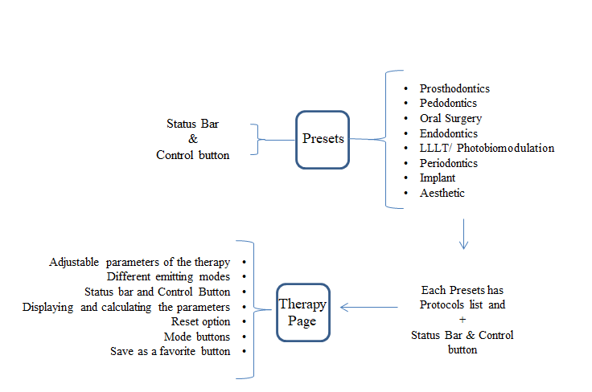
Figure 10- GUI of the Presets page of Dental Laser Device

The Presets subpage offers users a selection of pre-defined settings (Protocols) or configurations that can be easily applied. Within Presets, there are eight distinct groups available:
• Prosthodontics
• Pedodontics
• Oral Surgery
• Endodontics
• LLLT/Photobiomodulation
• Periodontics
• Implant
• Aesthetic
Clicking on each group will display a list of protocols. These protocols can be found in the Output-Protocol file.
By selecting a specific protocol, users will be directed to a 'Therapeutic Page' dedicated to that protocol.

3.3.1-1. Therapeutic Page:
Upon accessing the therapy page, the user can start the therapy session using the suggested parameters on the device.
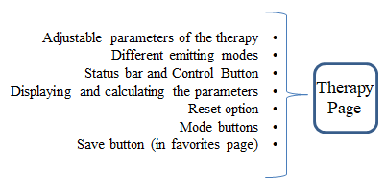
Figure 11- Block diagram of Therapy subpage

  - Parameters on the therapeutic page in Standby Mode:

• Emitting Mode: The laser beam can be selected in two modes - continuous and pulsed.

• Return button: By selecting this button, the user can reset the protocol settings to their original parameters before modification.

• Aiming beam indicator: By selecting this button, the aiming beam light can be turned on or off.

• Save button (Star button): By clicking on this button, users can save the protocol in favorites page.

• Time and Frequency buttons: The time of the emitting beam and its frequency in pulsed mode can be changed by selecting these buttons.

• Pulse duty cycle: The pulse duty cycle can be adjusted in a range of 1% to 99% with a step of 10%.

• Power of the laser: This parameter can be adjusted by changing the circular gauge or by touching the + and – buttons near the gauge.

• Laser Power and Average Power (not adjustable): These parameters show the set peak power and the average of the selected power.

• Wavelength buttons: The user can choose the desired wavelength for the therapy.

• Fiber type (just for display): This option recommends the suitable fiber type based on each protocol.

• Standby button: By selecting this button, the user can access the "ready mode page" of the therapy.

- Parameters on the therapeutic page in Ready/Emitting Mode:
• Emitting Mode
• Return button
• Aiming beam indicator
• Save button
• Power of the laser
• Laser Power and Average Power (not adjustable)
• Wavelength buttons
• Ready button (not adjustable): By tapping on standby button, this button is change to the ready mode then by pressing the footswitch, the "Emitting Mode Page" of the therapy becomes accessible, and the parameters in the Emitting mode page are the same as those in the Ready mode page.
• Total Time (not adjustable): The time set in standby mode will be displayed here.
• Timer (not adjustable): This parameter functions as a countdown timer and is set to the previously specified time.
• Total Energy (not adjustable): The total energy of the beam is calculated and displayed by this parameter.
If the user modifies the adjustable parameters of the pre-defined protocols, the Therapy page will be transformed into the Customize page. This allows the user to customize the therapy according to their specific needs and preferences and if the user modifies the adjustable parameters while in the ready mode, the therapy mode will change back to standby. The standby mode allows the user to review and adjust the parameters without affecting the current therapy session.

3.3.2. Customize:

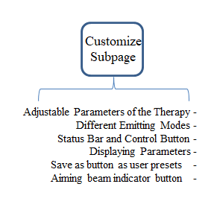
Figure 12- Block diagram of customize subpage

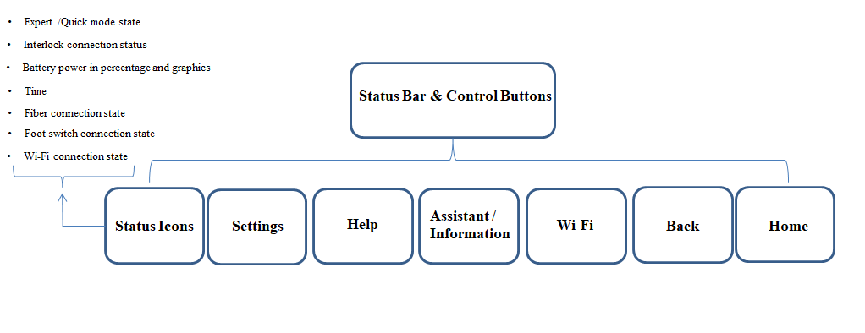
Figure 13- The Block diagram of status bar and control button in Customize Page

In the Customize subpage, users have the ability to personalize settings according to their specific preferences or requirements. This allows for a more tailored therapy experience.
However, it's important to note that the 'Recommendations' and 'Procedure' options, which are available in the assistant menu by tapping on the control button on the top right of the page, are specifically designed for the Presets subpage. These options provide additional functionality and guidance for utilizing the pre-defined protocols effectively.
In the Customize page, these specific options are not available. Instead, users have the freedom to customize the therapy parameters without the additional guidance provided by the 'Recommendations' and 'Procedure' options. This allows for more flexibility and personalization in creating a therapy plan that meets their individual needs.

3.3.3. Favorites:
The Favorites subpage provides a convenient location to save and quickly access the desired predefined protocols from preset section. It also offers the ability to search for specific protocols and delete them by performing a long press on each entry.
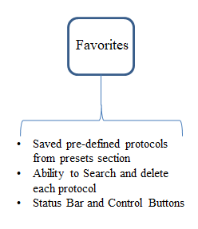
Figure 14- GUI of the Favorite page of Dental Laser Device

3.3.4. Q-Start:
In the Q-start subpage, users have the convenience of quickly initiating radiation by selecting the pulse mode, wavelength, power level, and pulse width through the Quick Experience mode.

3.3.5. History:
On this page, users can view a list of the ten most recently used presets. This feature provides quick access to the presets that have been recently utilized by the user.

3.3.6. User presets:
In the User Presets feature, users have access to a personalized list of programs that they have customized and saved with their desired names. To manage the User Presets, users can perform a long press on each protocol and delete them.

3.4. Other Icons
The following icons are only visible on the home page and are not present on other pages and subpages:
- Display User Name and Mode: This icon displays the user's name and mode, indicating whether they are in Quick or Expert mode.
- Exit button: The Exit button provides users with the option to log out of their current user account and enter another username and password.

4. Data Flow of GUI Software:
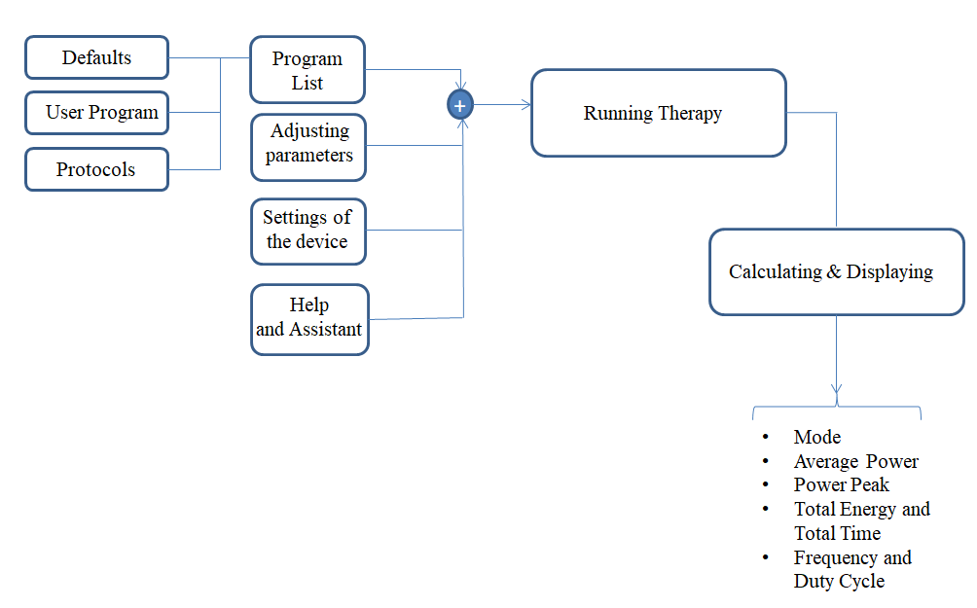
Figure 15- Data flow of GUI Software

B) Driver Software
In this section, Driver software requirements have been transformed into the ARCHITECTURE that describes the software's structure and identifies the SOFTWARE ITEMs.

There are several key functions performed by the driver software. Firstly, at a frequency of 1ms, the software evaluates all the software timers. Every 200ms, it reads all the ADCs (Analog-to-Digital Converters). Additionally, every 300ms, the software manages all the battery processes. It also checks the status of the footswitch, fiber, and interlock. Furthermore, it handles the laser emitting processes for wavelengths of 450nm, 650nm, and 980nm, as well as performs the necessary panel control processes. Lastly, the driver software controls the device's fan and LED.

2. Architecture of the Interfaces of SOFTWARE ITEMS
Serial Communication between GUI and Driver Software
In serial communication between GUI and Driver software, bytes of data are:
- General Structure:
- Byte definitions:
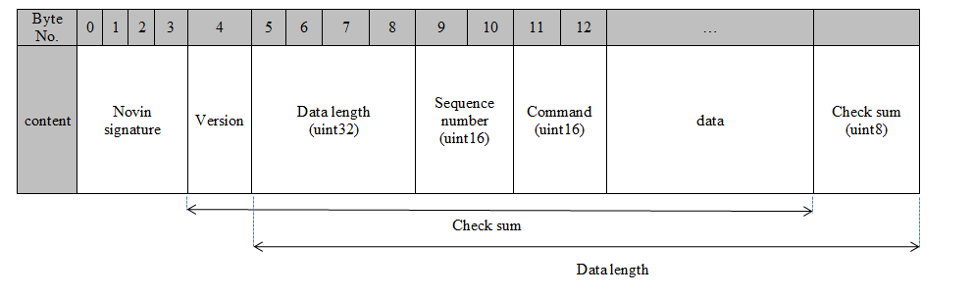
Ack command byte: 0xaaaa
Sequence number is the number of packets that has been received so far.
Check sum is the XOR of “version”, “data length”, “sequence number”, “command”, and “data” bytes.
Data length is the number of bytes from “data length” to the end of the packet.
The time interval between sending two packets should be more than 10 milliseconds.
All data is Little-endian.
Baudrate = 115200

  - Commands:
- Panel to main command:
STOP:
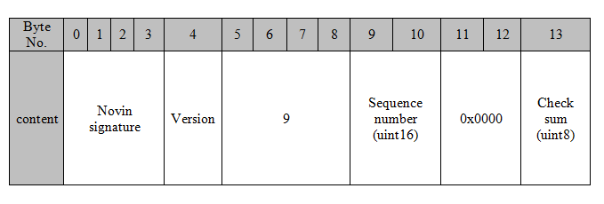
- Main to panel command:
If the command is received correctly and no error has occurred, the receiver will send an ACK response.
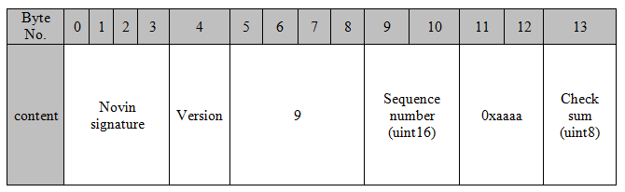
- Panel to main command:
START:
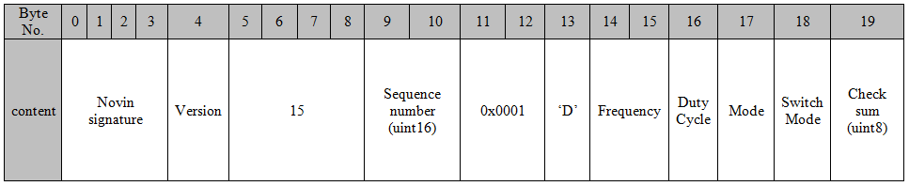
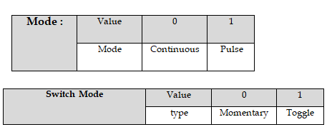
- Panel to main command:
Set Power:
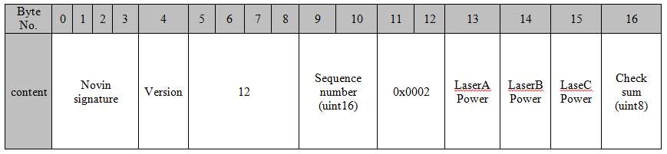
LaserA => Laser 980
LaserB=>Lasr 450
LaserC=> Laser 650
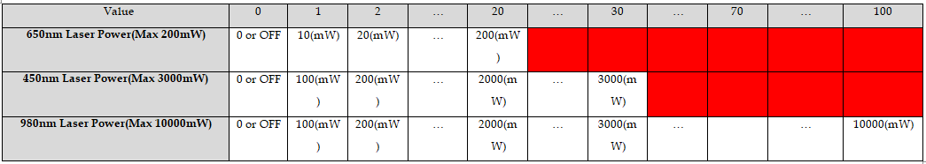

Save Calibration Table:
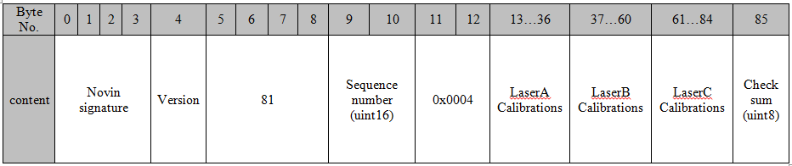
Caution: ACK response in this command does not mean that data is saved in flash successfully. It only means data received correctly.
Calibration points=> (each laser has 12 calibration points. Each point is 2 bytes)

- Panel to main command:
Read Status:
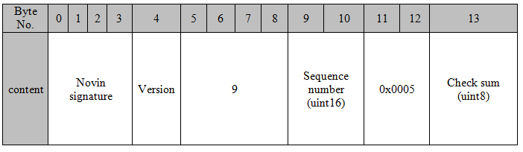

- Main to panel command:
Send Status:
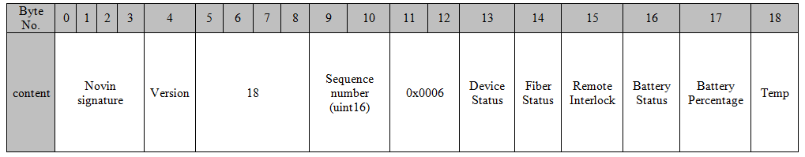
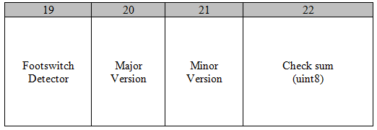
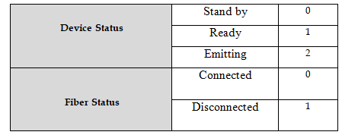
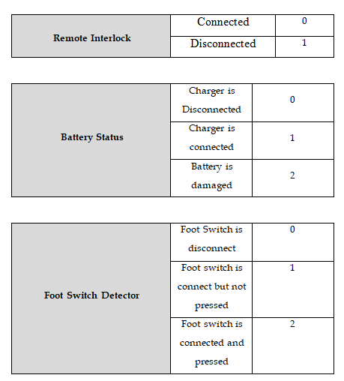
- Panel to main command:
Read Calibration Table:
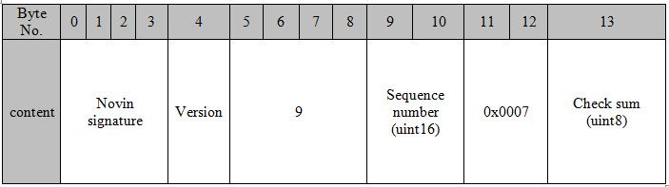
- Main to panel command:
Send Calibration:
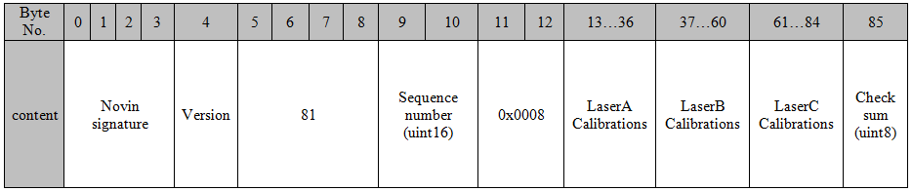
- Main to panel command:
Send power for calibration:
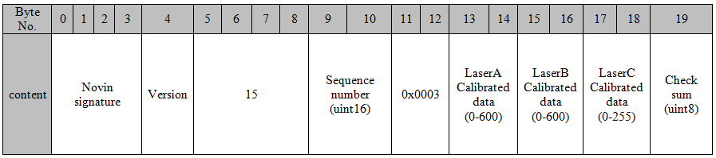
LaserA => Laser 980
LaserB=>Laser 450
LaserC=> Laser 650
Laser Points (mWatts):
- Panel to main command:
Set Aiming Beam Level
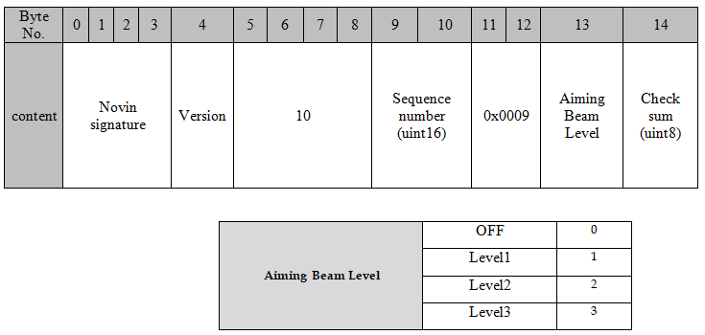

3. Software Architecture Verification
The software architecture is not complete unless all software requirements can be implemented by the identified software items which mentioned in before sections.
Because the design and implementation of the software is dependent on the architecture, the architecture is verified to complete this activity. Verification of the architecture is generally done by technical evaluation.
Software verification has been completed, and the details are documented in the following references: Second Page of "Software System Testing_Dental Laser/ Verification Sheet, Document Code: 15017," "GUI Software Testing_Dental Laser, Document Code: 15016," and "Driver Software Units Testing_Dental Laser, Document Code: 15024.”

4. Segregation Necessary for RISK CONTROL [For Class C]
No specific requirement is needed.

5. Functional and Performance Requirements of SOUP Item

1. GUI Software
In this section, we will define the functional and performance requirements for the identified SOUP items, which in our case are the Operating System (Linux) and the libraries used in the GUI software.

- Operating System (Linux)

Functional Requirements:
  - The operating system must support hardware acceleration for graphical operations.
  - It should provide necessary system calls for file management, process control, and device I/O.
  - Must support multi-threading to allow for responsive user interactions.
  - It must be capable of handling serial communication protocols to facilitate communication between the GUI software and the Driver software.
  - Audio unit to play feedback sounds

Performance Requirements:
  - The OS must boot within a specified time (≤10 seconds).
  - It must ensure that the latency for GUI updates is within acceptable limits (≥30 fps).
  - The system should be able to handle a minimum of 10 concurrent user interactions without degradation of performance.

- Libraries

Functional Requirements:
  - Libraries must include necessary API functions to support OpenGL renderer calls and GPU memory must be preserved in order to make sure future call will run without any issues
  - Each library should facilitate the integration of GUI elements with the underlying hardware.
  - Audio software encode/decode support

Performance Requirements:
  - The execution time for library functions should not exceed defined limits (e.g., rendering operations should complete within milliseconds).
  - Resource consumption (CPU and memory usage) must remain below specified thresholds to ensure optimal performance of the GUI.

2. Driver Software
In our design, there are no driver software items classified under the following two categories:
- Software items that are already developed and generally available, which were not specifically created for incorporation into the medical device.
- Software items previously developed for which adequate records of the development processes are unavailable.
As such, this requirement is not applicable to the Dental Laser driver software.

6. System Hardware and Software Required by SOUP Item

1. GUI Software
This section outlines the hardware and software dependencies necessary for the proper operation of the identified SOUP items.

- Hardware Requirements
- Processor:
Quad-core 64-bit Broadcom BCM2837 ARM Cortex-A53 SoC processor running at 1.2 GHz.
- Memory:
1GB Random access memory, 250MB will be allocated for GPU shared memory.
- Display:
Vertical ITF (In-Cell Touch Framework) touch support display is required for touch input from screen where the touch functionality is integrated directly on the LCD panel itself.
- Peripherals:
  - Storage: MicroSD card
  - Network adapter: Ethernet network card
  - USB 2.0 ports: 1

802.11n wireless LAN (WiFi)

- Software Requirements
- Operating System:
  - Custom Debian base OS (Kernel 5.x>) required
  - VideoCore IV® support
  - EGLFS Support for direct render calls
  - OpenGL 1.3 or higher recommended for smooth performance in modern environments.
- Libraries:
  - QtCSV for high performance file operation based on csv
  - WiringPi to interact with IO ports
  - LibVLC for audio feedbacks playback
  - DBUS
  - QT Framework

2. Driver Software
In our design, there are no driver software items classified under the following two categories:
- Software items that are already developed and generally available, which were not specifically created for incorporation into the medical device.
- Software items previously developed for which adequate records of the development processes are unavailable.
As such, this requirement is not applicable to the Dental Laser driver software.

7. Software Specifications
Driver Software | GUI Software
Keil | QT Creator | Code Environment
C++ | C++ and QML | Programming Languages
- | QT 5.12.11 | Framework
Keil Compiler | GCC | Development Compiler
- | Linux | Operating System
Arm Microcontroller  (STM32F207/217) | Raspberry pi 3B+ | Hardware
1 | 7.0.0.7650 | Software Version

8. Reference to Documents
Refer to the following documents for detailed information:
- Software Risk Management Report – Document Code: 15021
- Risk Management File – Document Code: 15044
- Risk Management Plan – Document Code: 15038
- Risk Management Report – Document Code: 15020
- Safety Characteristics – Document Code: 15034
- Software Problem Resolution – Document Code: 15866

Software Of Unknown Provenance (Refer to definition 3.29 in IEC 62304: 2006+AMD1:2015)

